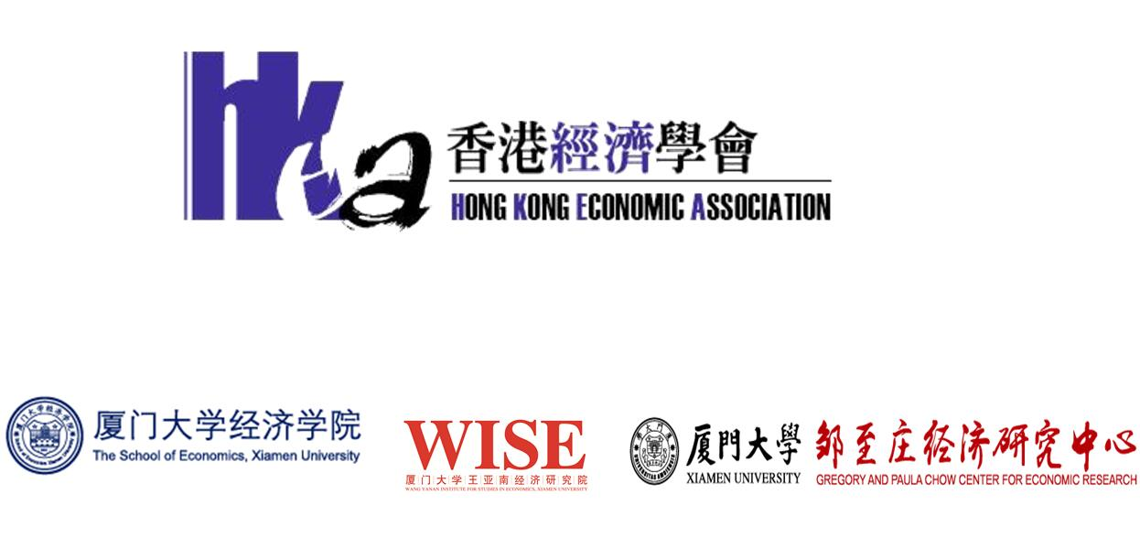

10th Conference of Hong Kong Economic Association
December 14 to 15, 2018
Xiamen University, Xiamen, P.R.China

Individual Registration Form

Please email the completed registration form to hkea@hkea.org.hk before November 1, 2018

Name: (Professor/Dr./Mr./Ms.*) __________________________________________________ Organization: ___________________________________________________________________ Address: _______________________________________________________________________ _______________________________________________________________________________ Country: ___________________________ Email: ___________________________________
Phone Number: ______________________ Fax Number: _____________________________

*Please circle the appropriate title.
Registration Fee | US$ | HK$
HKEA Members | 200 □ | 1580 □
Non HKEA Members | 250 □ | 1980 □ 1
Students | 100 □ | 780 □
Total Amount Paid:

1. Registration fee includes one-year HKEA membership.
2. Please check the appropriate items and currencies, and provide total amount.
3. Please refer to Appendix 1 for Payment Instruction.

APPENDIX 1
Payment Instruction

Payment can be made in either way:

1. Money Remittance:
Remit the payment to the following bank account:
Bank Name: THE BANK OF EAST ASIA LIMITED
Bank Address: 10 Des Voeux Road, Central, Hong Kong
Account Holder: Hong Kong Economic Association
Account Number: 015-514-40-52800-5 (SWIFT Code: BEASHKHH)

Please scan the Remittance Receipt and email it together with the completed Registration Form to: hkea@hkea.org.hk

2. Cheque or Bank Draft Payment:
Make a cheque or bank draft, payable to “Hong Kong Economic Association” and send it with the completed Registration Form to:

Professor Larry Qiu, Hong Kong Economic Association
Faculty of Business and Economics
The University of Hong Kong
Pokfulam Road, Hong Kong

